**BI Project Proposal**

**Recognize the business problem**

Given that Business Analysis is the framework for identifying, clarifying and developing solutions to an organizational problem, therefore given the context of Mr.Michel's situation we need an action plan in which the management of different steps will be necessary to propose a solution, we will study and precisely analyze the data. It is critically important to understand the problem faced by the store in order to provide recommendations that can address the needs of the company and use our skills in data analysis to find corresponding solutions.

●**The business problem**  
The problem of the company is: should Mr. Michel continue with the sale of tomatoes or not? That is, is the business profitable or not according to its current mode of operation. As a group of Data Analysts we will analyze the data of the first three months in order to propose to Mr. Michel the best possible answer for this question.

**●The problem significance to the organization**

Mr. Michel has invested in his store to sell tomatoes for which he has identified a demand. The essence of any investment is the search for maximum profit, taking into account the constraints resulting from the demand and the perimage of the products. It is therefore very important for Michele to find the best strategy that can help him eliminate his probable losses and increase his profit to the maximum.

**Research the organization**

To do our job well as a data analyst and propose the best possible solution, we need the key elements of the store :

**●The objective of the organization**

L’objectif principal de de Michèle est de faire du profit le maximum possible. Par la, il essaie tout de même de répondre aux besoins de sa communauté de tomates.

**●The values of the organization**

Au-delà de la recherche du profit, Michele semble honnête dans la vente de ses produits, il refuse de vendre ces produits périmés alors qu’il fait des pertes exagérées. C’est très important et ce sera pris en compte dans nos analyses et recommandations.

**●Other organizations the organization interacts with**

Michele interacts en tres grande partie avec son fournisseur qui lui livre les produits regulierement.

**●How does the organization measure success**

Michel's measure of success is knowing the information about whether or not to stop trading tomatoes. for his son, it is likely to be complying with his father's measure

The measure of success for the supplier could be continuing to do business with Michael.

**Identify your client**

The problem was identified by Mr Michel the owner and he told his son about it but nothing was done to deal with it.

The solution will be proposed to the son of Mr. Michel. The customer is concerned about his orders of tomato paste. For the last three months the business owner has made no profit on the tomato paste cans. That is the reason why he went and talked to his son about it.

He measures success especially through the benefits. He has come to understand that he was heading in the wrong direction. He expected us to provide him with the best solution to remedy this situation and increase his profits.

●**Who are the relevant stakeholders**

The people who are really affected by the problem:

1. Michel the shop owner
2. Michel’s son (the client)
3. The suppliers

c) The customers

**Identifying other relevant stakeholders**

The stakeholders who are impacted by the problem are the owners (Michel and his son), the supplier, and the customers. All of them will be affected by the decision to continue or not to sell tomato paste. The owners are the most concerned about the problem; they want to know if the selling of tomatoes is beneficial to them and how to maximize their profit. The suppliers are also concerned by the problem because the decision of reducing or increasing the amount of tomato will affect their income. They would not like to lose Michel as a client. Finally, the consumers are concerned because they buy the tomato paste from Michel. The increase or decrease in the offered amount will impact the prices and therefore, their consumption and their welfare.

●What authority or power does each stakeholder have?

●How is the business problem affecting the stakeholder?

5. Conceptual Model

A partir des données recueillies au cours des 3 derniers mois, on a effectué des analyses pour comprendre la vente et le roulement du stock dans la boutique pour les tomates. On a realise une sorte de diagnostique pour la periode donne

Models help to explain the context that the business problem is occurring within. Models are used by the

analyst to help clarify their understanding of the problem and communicate their understanding to

others.

This step is iterative, the analyst should return to the client and organization to validate the

conceptual model.

Conceptual Models should include the following information:

●Identify the problem

●Identify the stakeholders

●Identify relationships between stakeholders

SWOT Methodology

Strengths - Identify strengths within the system.

Knowledge, resources, location, or timing.

Weaknesses - Identify weaknesses within the system.

Lack of information, missing tools, or deadline.

Opportunities - Events which can help generate value

from the system or improve the system.

Threats - Events which can deteriorate or reduce the

value of the system.

**Results**

A partir des données recueillies au cours des 3 derniers mois, on a effectué des analyses pour comprendre la vente et le roulement du stock dans la boutique pour les tomates. On a réalisé une sorte de diagnostique pour la période donne. Le graphique ci dessous donne une idee claire des achats, ventes, pertes et le reste de tomates.

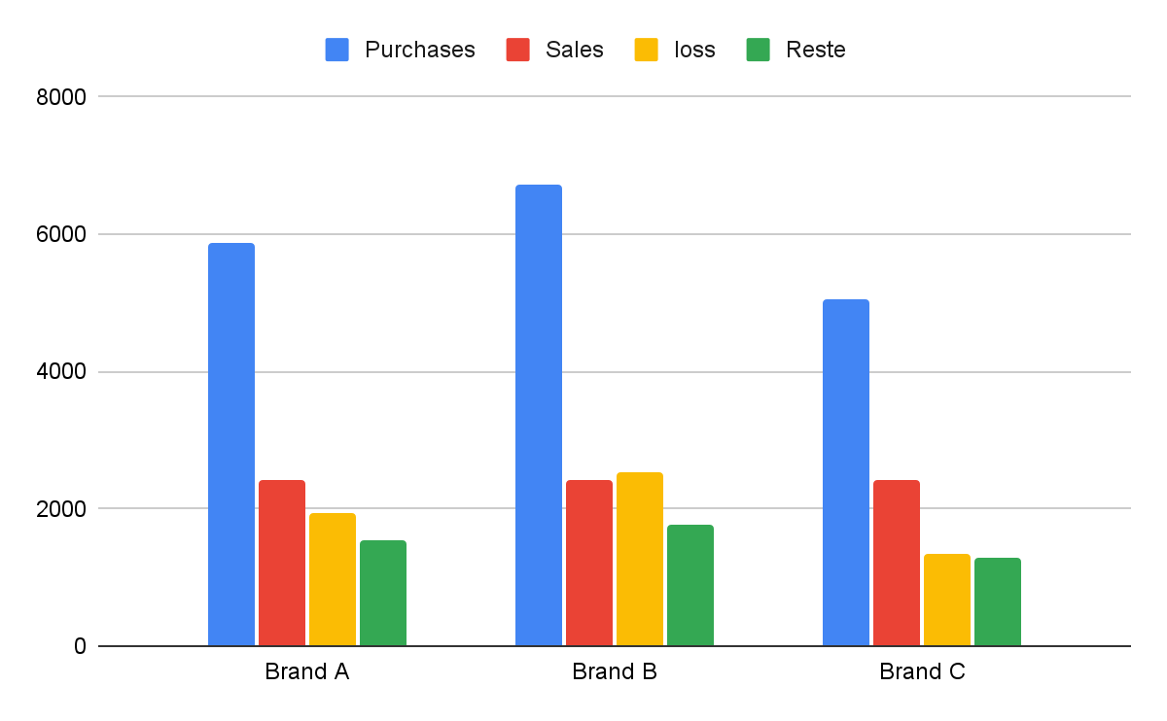

On observe que la quantité vendue de chaque Brand approche plus ou moins la quantité perdue. Pour les trois, il n’arrive à écouler que 40,9% de ses achats. On arrive même à constater que la quantité vendue est inférieure à celle perdue pour la Brand B.

Ces pertes sont énormes.

On a procédé à l'évaluation des pertes par Brand, et le résultat trouvé et présenté par le prochain graphique est catastrophique.

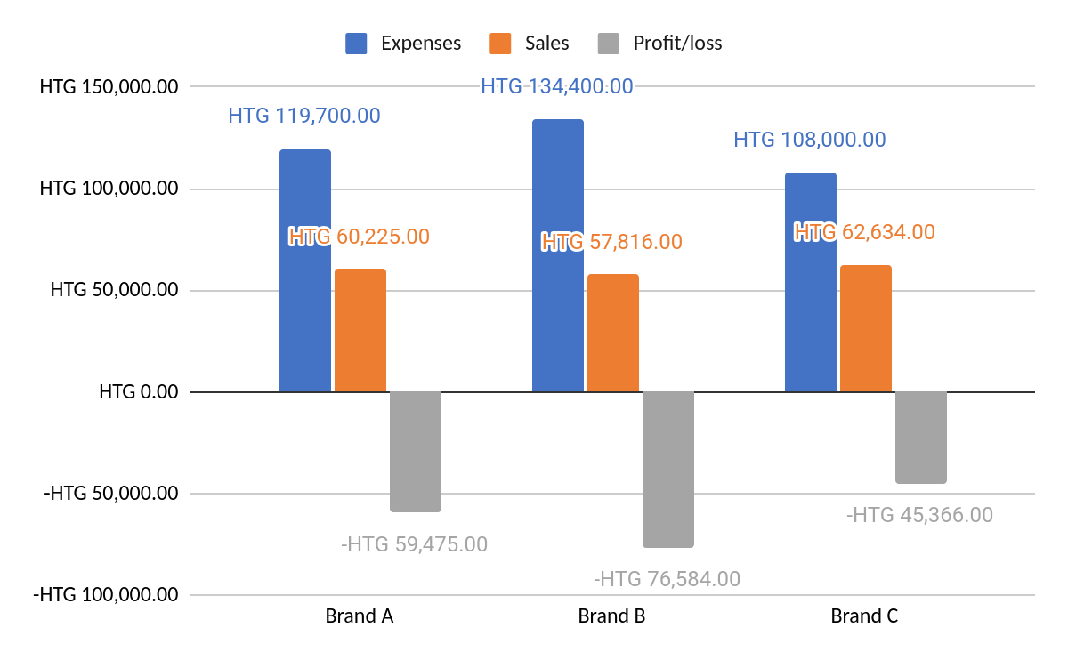

Sur tous les 3 mois, la boutique enregistre une perte de plus de 59 000 gourdes pour le Brand A, d'environ 76 500 pour la Brand B et de 45 336 gourdes pour la C.

La structure de la demande devra beaucoup nous renseigner sur la préférence des clients de Michèle par rapport à chaque Brand de tomates

Nous decouvrons que Michele vend pour Chaque Brand tous les jours la meme quantite. C’est difficile de faire ressortir une tendance à partir des ventes quotidiennes, néanmoins, on a pu constater une décroissance moyenne des ventes de 1% .

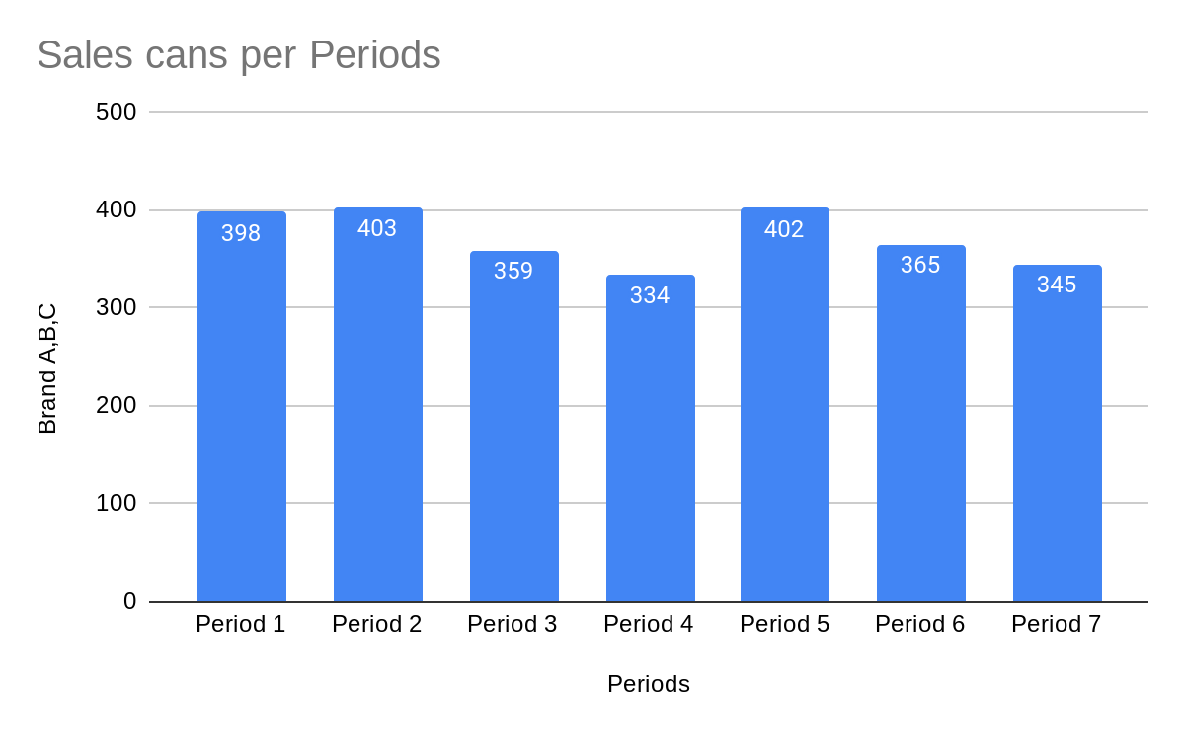

Le graphique susmentionné présente les ventes pour chaque période fixe selon la date des commandes, la quantité de canettes vendues ne dépasse pas 403 pour une période. Or Michele fait régulièrement des commandes de 840, 960 et 720 pour respectivement B et C.

Il a l’obligation de vendre ses produits avant la fin du mois, sinon il ne pourra plus les vendre. Cette contrainte engendre des conséquences que Michèle devra subir profondément, le graphique suivant en est une illustration de taille pour la Brand A.

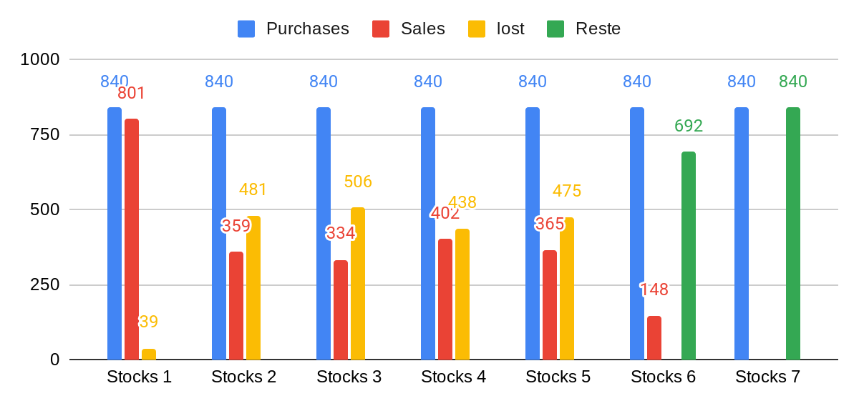

A partir du graphe présente en haut, on voit que les pertes sont a chaque fois superieure aux ventes puisque Michele n’attend pas la fin du stock pour en commander un autre alors que ces produits ne resistent plus apres 1 moi. Les deux dernieres commandes en sont des exemples, alors qu’il lui reste 692 cannetes de tomates a vendre, il decide tout de meme d’augmenter son stock 840 de. En fin de compte, la seule commande qui lui est rentable est la premiere. Ce qui ne répond à aucune logique de management.

Une analyse comme celle ci est faite pour chaque Brand séparément et on comprend que le roulement des stocks est mal fait.

En plus du stock qui est mal géré, la vente diminue progessivement.

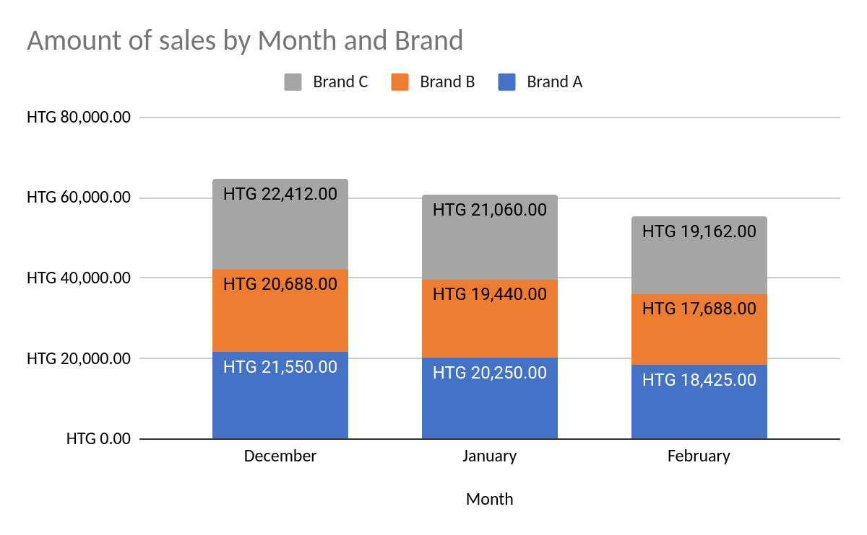

Pour la Brand C, la vente est passée de 22 412 gourdes à 19 162 gourdes, soit une baisse d’un peu moins de 5%. On peut toutefois remarquer que malgré cette baisse, Michele ne fait pas varier ses commandes. Il en est de même pour la Brand B dont les ventes passent de 20 688 gourdes à 17 688 gourdes. Pour la Brand A, de 21 450 a 18 425 gourdes.

La demande est en train de baisser continuellement, il faut une réponse qui puisse adapter les commandes et le stock à la nouvelle dynamique du marché.

**Develop Alternative Solutions**

1. Solution 1

La boutique de Michele enregistre des pertes sur pratiquement toutes les commandes, il n’arrive jamais à faire écouler ses produits. Pour les deux dernières commandes dont les produits n’expirent pas encore, nous recommandons une liquidation des canettes pour au plus le prix d’achat.

Cette solutions permet de réduire les per

Once the problem is understood, the analyst should define the requirements thats must be fulfilled to

address the problem. With defined requirements, the analyst should work with the client and other key

stakeholders to brainstorm potential solutions that meet the requirements that have been defined. The

analyst should try to identify the value created to the various stakeholders by each proposed solution.

Potential Solutions should include:

●How does the solution address the problem

●Cost to implement the solution

●Who will be affected by the solution

●Timeframe to implement the solution

●Risks in deployment of the solution

7. Present the solutions

Once the solutions have been sufficiently developed with the client and key stakeholders, the analyst

must present the solutions to the organization. The analyst should use the information gathered in each

step to provide the organization with further information regarding the business problem. It is important

to note

the analyst is not the decision maker

and should provide all the information effectively for the

organization to make a decision.

Key aspects of the presentation:

●

Clarify the business problem

●

Identify all the relevant stakeholders

●

Definition of solution requirements

●

Proposal of solution alternatives and the necessary information regarding those solutions

